Tax Information for 2023 Cash Distributions

Information for the federal income tax treatment of 2023 distributions paid by eXp World Holdings, Inc. (the “Company”) (Nasdaq: EXPI) (CUSIP Number: 30212W100) to holders of its common stock is set forth below..

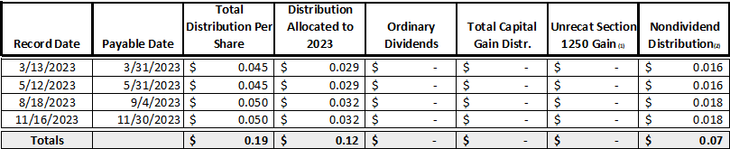

(1) This is the amount included in the Total Capital Gain Distribution that is Unrecaptured Section 1250 gain.
(2) This amount represents a non-taxable distribution treated as a return of capital.
(3) This amount represents dividends eligible for the 20% qualified business income deduction under Section 199A, and is included in Ordinary Dividends.

This information is being provided to assist shareholders with tax reporting related to distributions made by the Company. Taxability of 2023 distributions is not necessarily indicative of taxability of future distributions. The tax information provided herein should not be construed as tax advice and shareholders are encouraged to consult with their tax advisors as to their specific tax treatment of the Company's distributions.

If you have any questions about this information, please contact eXp World Holdings, Inc. Investor Relations at investors@expworldholdings.com.

